Store Dataset Report
Introduction

This dataset contains retail sales data, featuring customer demographics (Gender, Age Group), transaction details (Order ID, Status), product specifics (Category, SKU), and shipping details. Our analysis focuses on understanding customer behavior and product trends to reveal patterns and preferences. These insights empower businesses to enhance marketing strategies, optimize inventory management, and improve customer satisfaction levels.

Questionnaire
1. Compare various channels based on how many male customers order and female customer order.
2. Compare all the categories of order where amount is less than 1500 and greater than 5000.
3. How many Customers are there whose age is 30 and above and state is Delhi.
4. Which of the following state perform better than other, Delhi, Tamil Nadu, Maharashtra, Rajasthan.
5. Which city performed better than all other cities based on highest order placed.
6. Compare various categories of items based on most quantity sold and show which gender buys the most category.

Analytics
Q1. Compare various channels based on how many male customers order and female customer order?
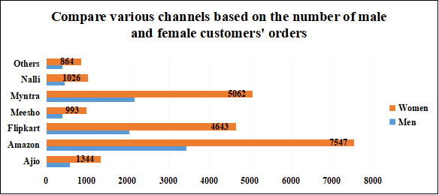
ANS: Amazon leads in both men's and women's categories, outselling Myntra and Flipkart. Approximately 3,432 units were sold by Amazon in men's fashion, and nearly 7,547 units in women's fashion. Myntra sold around 2,156 units for men and 5,062 units for women.

Q2. Compare all the categories of order where amount is less than 1500 and greater than 5000.
ANS: This analysis compares order categories with amounts less than 1500 and greater than 5000. Kurta and set have the highest order counts, followed by western dress, top, and saree, indicating consumer preferences across different price ranges.
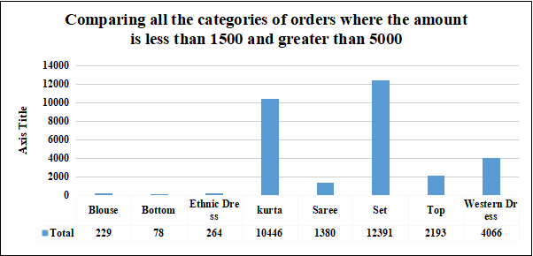
Q3. Which of the following state perform better than other, Delhi, Tamil Nadu, Maharashtra, Rajasthan.
ANS: This analysis identifies states outperforming those mentioned earlier, with Karnataka leading at 2,646,358 units sold, followed by Uttar Pradesh at 2,104,659 units. These states demonstrate superior sales performance. Understanding the top-performing states allows businesses to focus resources effectively and tailor strategies to capitalize on high-performing regions for enhanced sales and profitability.
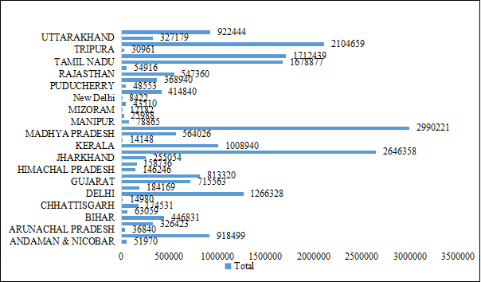
Comparision of the performances of Delhi, Tamil Nadu, Maharashtra, and Rajasthan

Q5. Which city performed better than all other cities based on highest order placed.
ANS: According to the recorded graph, Bangalore emerges as the top-performing city with the highest number of orders placed, totaling 2,673 orders, followed by Hyderabad with 1,998 orders. This indicates Bangalore's strong market presence and significant order volume.
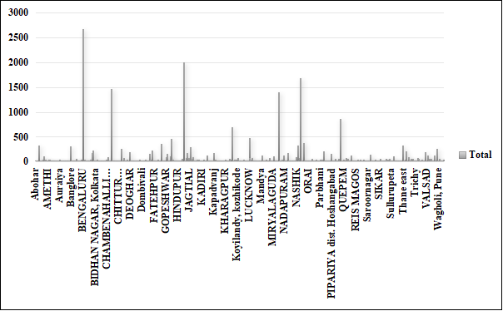

Q6. Compare various categories of items based on most quantity sold and also show which gender buys the most category.
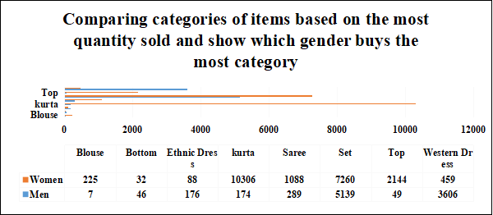

ANS: The analysis underscores the popularity of kurta and set purchases among women, with kurta being the most bought item, followed by set. For men, western dress emerges as the top choice, while top is favored by both men and women, indicating its universal appeal across genders.
Conclusion and Review
The analysis underscores Amazon's dominance in men's and women's categories, with Myntra and Flipkart trailing closely. Leading sales items include kurta and set, with Karnataka and Bangalore demonstrating exceptional performance. These insights offer valuable guidance for retailers, although delving deeper into other sales-influencing factors could enrich the analysis. Overall, the findings provide crucial insights for refining sales strategies in competitive market landscapes.
Regression
SUMMARY OUTPUT
Regression Statistics
Multiple R | 0.172398
R Square | 0.029721
Adjusted R Square | 0.029659
Standard Error | 264.5693
Observations | 31047
ANOVA
 | df | SS | MS | F | Significance F
Regression | 2 | 66561870 | 33280935 | 475.4629 | 0
Residual | 31044 | 2.17E+09 | 69996.92
Total | 31046 | 2.24E+09
 | Coefficients | Standard Error | t Stat | P-value | Lower 95% | Upper 95% | Lower 95.0% | Upper 95.0%
Intercept | 185.155 | 16.57854 | 11.16836 | 6.61E-29 | 152.6604 | 217.6496 | 152.6604 | 217.6496
X Variable 1 | 0.047626 | 0.099327 | 0.479489 | 0.631594 | -0.14706 | 0.242312 | -0.14706 | 0.242312
X Variable 2 | 492.0276 | 15.95904 | 30.83065 | 1.3E-205 | 460.7472 | 523.308 | 460.7472 | 523.308

Anova (One factor)
Anova: Single Factor
SUMMARY
Groups | Count | Sum | Average | Variance
Column 1 | 31047 | 31237 | 1.00612 | 0.008853
ANOVA
Source of Variation | SS | df | MS | F | P-value | F crit
Between Groups | 7.2E+09 | 1 | 7.2E+09 | 199639.8 | 0 | 3.841609
Within Groups | 2.24E+09 | 62092 | 36068.2
Total | 9.44E+09 | 62093

Anova (Two factor)
Anova: Two-Factor Without Replication
SUMMARY | Count |  | Sum |  | Average |  | Variance
Row 1 | 3 |  | 421 |  | 140.3333 |  | 42116.33
Row 2 | 3 |  | 1479 |  | 493 |  | 685648
Row 3 | 3 |  | 521 |  | 173.6667 |  | 59609.33
Row 4 | 3 |  | 750 |  | 250 |  | 172171
Row 5 | 3 |  | 607 |  | 202.3333 |  | 88482.33
Row 31044 | 3 |  | 974 |  | 324.6667 |  | 283326.3
Row 31045 | 3 |  | 1145 |  | 381.6667 |  | 403529.3
Row 31046 | 3 |  | 446 |  | 148.6667 |  | 47506.33
Row 31047 | 3 |  | 828 |  | 276 |  | 199225
Column 1 | 31047 |  | 1226250 |  | 39.49657 |  | 228.5307
Column 2 | 31047 |  | 31237 |  | 1.00612 |  | 0.008853
Column 3 | 31047 |  | 21176377 |  | 682.0748 |  | 72136.38
ANOVA
Source of Variation |  | SS |  | df |  | MS |  | F |  | P-value | F crit
Rows |  | 7.49E+08 |  | 31046 |  | 24134.08 |  | 1.000774 |  | 0.468198 | 1.016275
Columns |  | 9.09E+09 |  | 2 |  | 4.54E+09 |  | 188446.6 |  | 0 | 2.995877
Error |  | 1.5E+09 |  | 62092 |  | 24115.42
Total |  | 1.13E+10 |  | 93140

Descriptive Statistics
Column1 |  | Column2 |  | Column3
Mean | 39.49657 | Mean | 1.00612 | Mean | 682.0748
Standard Error | 0.085795 | Standard Error | 0.000534 | Standard Error | 1.524289
Median | 37 | Median | 1 | Median | 646
Mode | 28 | Mode | 1 | Mode | 399
Standard Deviation | 15.11723 | Standard Deviation | 0.094088 | Standard Deviation | 268.5822
Sample Variance | 228.5307 | Sample Variance | 0.008853 | Sample Variance | 72136.38
Kurtosis | -0.1587 | Kurtosis | 475.3566 | Kurtosis | 1.768676
Skewness | 0.72916 | Skewness | 19.4509 | Skewness | 1.052904
Range | 60 | Range | 4 | Range | 2807
Minimum | 18 | Minimum | 1 | Minimum | 229
Maximum | 78 | Maximum | 5 | Maximum | 3036
Sum | 1226250 | Sum | 31237 | Sum | 21176377
Count | 31047 | Count | 31047 | Count | 31047

Correlation
 | Column 1 | Column 2 | Column 3
Column 1 | 1
Column 2 | 0.004884 | 1
Column 3 | 0.003522 | 0.172377 | 1

